DSCI 5350 Spark Activity-4 Satyasriharsha Buddha

Spark ML pipeline-Activity 4

Import the File

Path - dbfs:/FileStore/shared_uploads/sriharshabuddha@my.unt.edu/Diamonds-1.csv

1)Load the dataset as a data frame

2) Print the schema of the data set.

3)Count the number of records and display first 10 records.

4) By default, the data type of price (Dependent variable) is taken as integer. We have to change that to double.

5)Display the top 5 records and verify the price column

Categorical feature- cut, color, clarity

Continuous feature-depth, x, y, z

6)Show distinct values in categorical features

7) Display the distinct values in cut. Click drop down in chart options and select bar chart

Select plot options and do the following settings

Value=<id> ; Series groupings=’cut’;Aggregation=COUNT

8) Visualize the continuous features

Depth-

Column X

Column Y

Column Z

Column Carat

Most of the diamonds are small . The above visualization shows a skewed distribution.

9) Using interactive SQL to explore the data

10) Create a temporary view

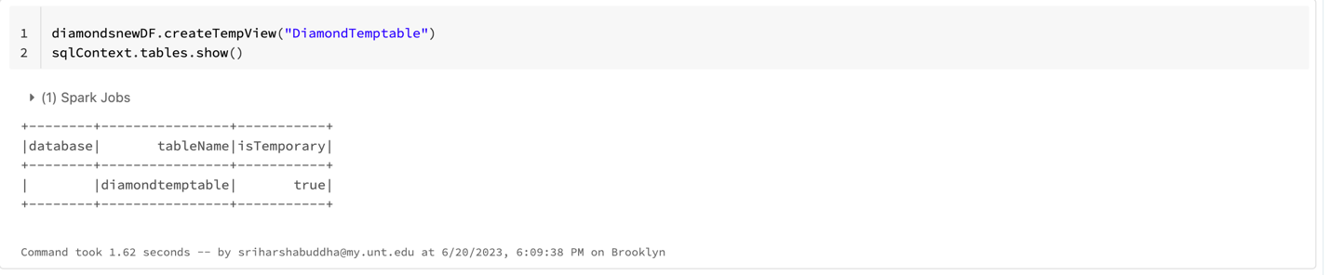

11) Write sql query to fetch data from the view

10) Select all the values from the temp table where clarity starts with ‘I’

11) Execute Aggregate function to get the average price of the diamonds

12)Display carat, clarity, price of top 5 records sorted by carat field

